**Spring MVC-**

In MVC, the whole functionality is divided into three parts as-model, view

and controller

**Model**- It can be an object or collection of objects which basically contains the data of the application which consist of POJO.

**View**- It is used for displaying the information to the user.

**Controller**- provides information between model and view. It contains the logical part of the application. *@Controller* annotation is used to mark that class as controller.

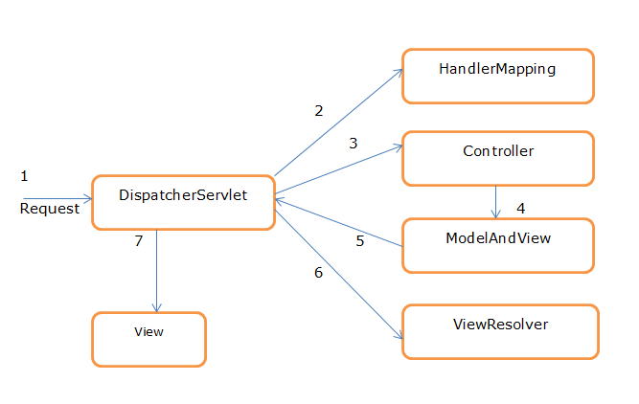

Fig- Spring MVC Flow

**Description-**

Step **1**:

When browser sent the request will be received by DispatcherServlet.

Step **2**:

DispatcherServlet will take the help of HandlerMapping and get to know the Controller class name associated with the given request.

Step **3**:

So request transfer to the Controller, and then controller will process the request by executing appropriate methods and returns ModeAndView object (contains *Model* data and *View* name) back to the DispatcherServlet.

Step 4:

Now DispatcherServlet send the model object to the ViewResolver to get the actual view page.

Step **5**:

Finally DispatcherServlet will pass the *Model* object to the *View* page to display the result.

**How to create the Spring MVC Project**

File->New->Other->type maven in wizard search box

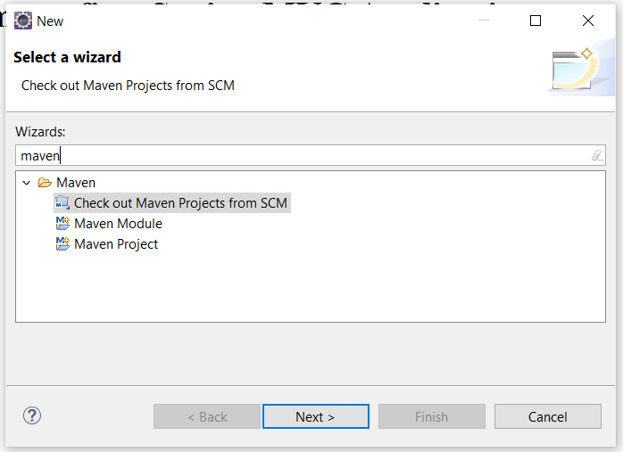

Click on Next Button and will see this window

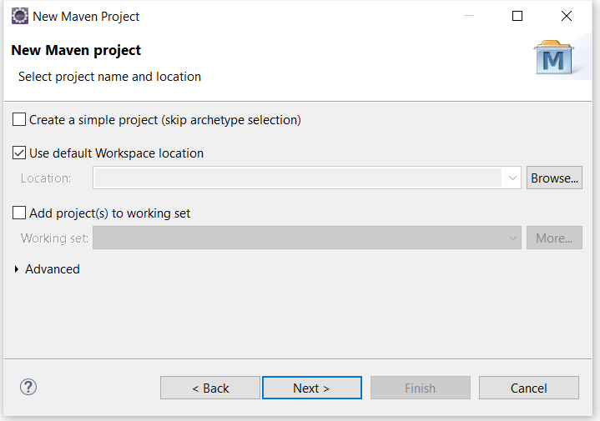

Click on Next button again and Select maven-archetype-webapp from Artifact Id as per below screenshot

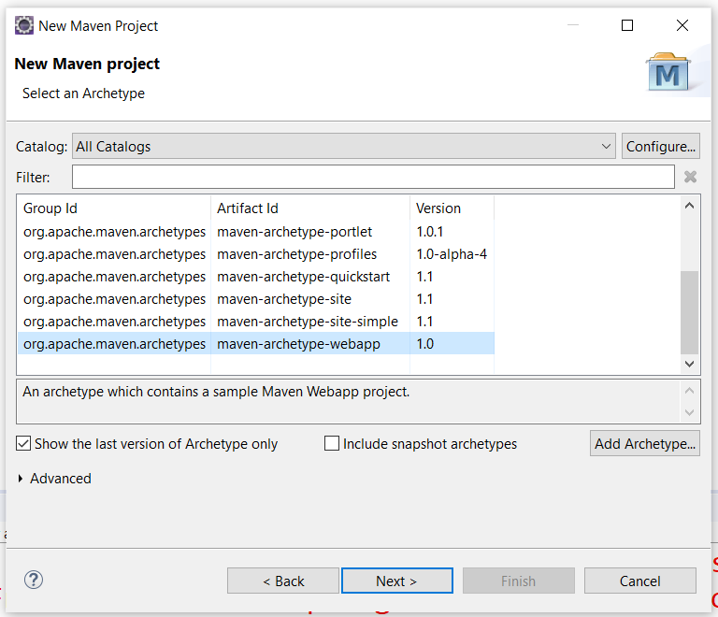

Click on Next button and Enter group and artifact id, click on finish button.

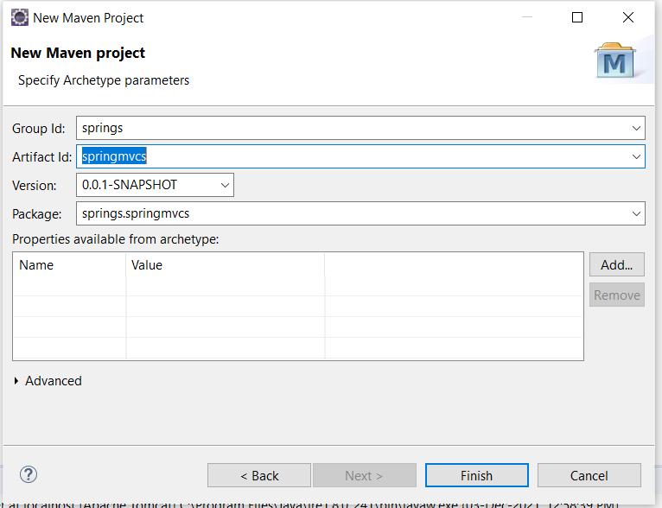

Then Spring MVC structure looks like, create views folder (Right click on WEB-INF Folder->New->Folder-> Type Folder Name->click on finish button) inside WEB-INF Folder.

**Spring-MVC folder structure**

**Example-1**

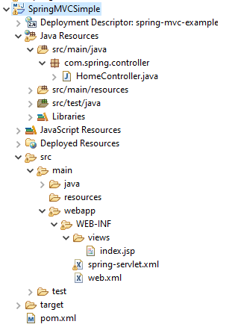

**index.jsp**

<%@ page language=*"java"* contentType=*"text/html; charset=ISO-8859-1"*

pageEncoding=*"ISO-8859-1"*%>

<!DOCTYPE html>

<html>

<head>

<meta charset=*"ISO-8859-1"*>

<title>Insert title here</title>

</head>

<body>

<h1>Welcome to first Spring MVC Application</h1>

</body>

</html>

**spring-servlet.xml**

<?xml version=*"1.0"* encoding=*"UTF-8"*?>

<beans:beans xmlns=*"http://www.springframework.org/schema/mvc"*

xmlns:xsi=*"http://www.w3.org/2001/XMLSchema-instance"* xmlns:beans=*"http://www.springframework.org/schema/beans"*

xmlns:context=*"http://www.springframework.org/schema/context"*

xsi:schemaLocation=*"http://www.springframework.org/schema/mvc http://www.springframework.org/schema/mvc/spring-mvc.xsd*

*http://www.springframework.org/schema/beans http://www.springframework.org/schema/beans/spring-beans.xsd*

*http://www.springframework.org/schema/context http://www.springframework.org/schema/context/spring-context.xsd"*>

<annotation-driven />

<context:component-scan base-package=*"com.spring"* />

<beans:bean

class=*"org.springframework.web.servlet.view.InternalResourceViewResolver"*>

<beans:property name=*"prefix"* value=*"/WEB-INF/views/"* />

<beans:property name=*"suffix"* value=*".jsp"* />

</beans:bean>

</beans:beans>

**Web.xml**

<?xml version=*"1.0"* encoding=*"UTF-8"*?>

<web-app xmlns:xsi=*"http://www.w3.org/2001/XMLSchema-instance"* xmlns=*"http://java.sun.com/xml/ns/javaee"* xsi:schemaLocation=*"http://java.sun.com/xml/ns/javaee http://java.sun.com/xml/ns/javaee/web-app_3_0.xsd"* id=*"WebApp_ID"* version=*"3.0"*>

<display-name>spring-mvc-example</display-name>

<!-- Add Spring MVC DispatcherServlet as front controller -->

<servlet>

<servlet-name>spring</servlet-name>

<servlet-class>

org.springframework.web.servlet.DispatcherServlet

</servlet-class>

<init-param>

<param-name>contextConfigLocation</param-name>

<param-value>/WEB-INF/spring-servlet.xml</param-value>

</init-param>

</servlet>

<servlet-mapping>

<servlet-name>spring</servlet-name>

<url-pattern>/</url-pattern>

</servlet-mapping>

</web-app>

**Pom.xml**

<project xmlns=*"http://maven.apache.org/POM/4.0.0"*

xmlns:xsi=*"http://www.w3.org/2001/XMLSchema-instance"*

xsi:schemaLocation=*"http://maven.apache.org/POM/4.0.0 http://maven.apache.org/maven-v4_0_0.xsd"*>

<modelVersion>4.0.0</modelVersion>

<groupId>spring</groupId>

<artifactId>SpringMVCSimple</artifactId>

<packaging>war</packaging>

<version>0.0.1-SNAPSHOT</version>

<name>SpringMVCSimple Maven Webapp</name>

<url>http://maven.apache.org</url>

<dependencies>

<dependency>

<groupId>junit</groupId>

<artifactId>junit</artifactId>

<version>3.8.1</version>

<scope>test</scope>

</dependency>

<dependency>

<groupId>javax.servlet</groupId>

<artifactId>servlet-api</artifactId>

<version>2.5</version>

<scope>provided</scope>

</dependency>

<dependency>

<groupId>javax.servlet</groupId>

<artifactId>jstl</artifactId>

<version>1.2</version>

</dependency>

<dependency>

<groupId>org.springframework</groupId>

<artifactId>spring-webmvc</artifactId>

<version>4.3.9.RELEASE</version>

</dependency>

<dependency>

<groupId>org.springframework</groupId>

<artifactId>spring-web</artifactId>

<version>4.3.9.RELEASE</version>

</dependency>

<dependency>

<groupId>javax.servlet.jsp</groupId>

<artifactId>jsp-api</artifactId>

<version>2.1</version>

<scope>provided</scope>

</dependency>

</dependencies>

<build>

<finalName>SpringMVCSimple</finalName>

</build>

</project>

**HomeController.java**

package com.spring.controller;

import org.springframework.stereotype.Controller;

import org.springframework.web.bind.annotation.RequestMapping;

@Controller

public class HomeController {

@RequestMapping("/")

public String display()

{

return "index";

}

}

How to Run Application-

Right click on Project and Run as ->Run on Server-

Note- <http://localhost:8080/spring-mvc-example/>

**Output-**

Welcome to first Spring-MVC Application